BIODIVERSITY AND CLIMATE CHANGE
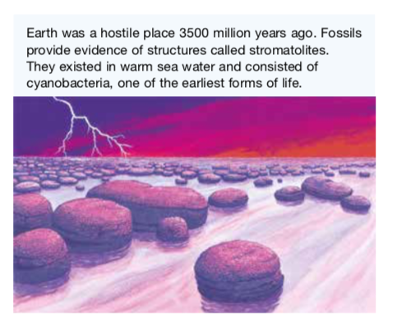
The evolution of life forms on Earth has occurred because some organisms are better suited to a particular environment than others.

For some to be better suited than others, there needs to be variation or diversity.

In a global sense, biodiversity refers to the total variety of living things on Earth, their genes and the ecosystems in which they live.

Species Diversity

All environments change over time.

It is the diversity (or variation) of the genetic information within the "gene pool" that contributes to the number of possible combinations that could be used to produce the next generation.

Increased variety in how this genetic information appears in the offspring (i.e. their traits) means an increased chance that some of these offspring will be able to survive in the environment in which they are born and will live - even if that environment changes.

If there is little variation in the gene pool, there is less chance of the offspring being able to survive possible changes in their environment, such as climate and the availability of habitat, food, mates or other resources.

The consequences of this limited diversity within the population may lead to the extinction of the species.

Ecological Diversity

Ecological diversity can be considered in terms of the diversity in ecosystems.

The extinction of a particular species within an ecosystem may affect the survival of other species within that ecosystem.

e.g. The extinct species’ disappearance will have consequences for the food supplies of others within its food web.

Unless there are other species that can take its place without having a negative effect on others, the survival of other species may be threatened.

Increased biodiversity within ecosystems can reduce the consequences of losing a species to which the survival of others is linked. Likewise, reduced biodiversity in these ecosystems can lead to the extinction of other species.

AUSTRALIA'S BIODIVERSITY

Biodiversity within Australian ecosystems is influenced by both biotic factors (e.g. plants and animals) and abiotic factors.

• Abiotic factors - those that contribute to climate (e.g. temperature and annual rainfall) can affect the abundance, distribution and types of species within a particular ecosystem.

Organisms have particular tolerance ranges for abiotic factors, outside of which they cannot survive.

If global warming results in the development of climatic conditions that are outside a species’ tolerance range, and if they are unable to migrate or adapt to the new conditions, then there is a threat that the species may become extinct.

Species that are most at risk are those that have:

• low genetic variability
• long life cycles and low fertility (birth rates)
• a narrow range of physiological tolerance and geographic range
• specialist resource requirements

Global Warming and Australia’s Biodiversity

Changes in Australia’s biodiversity that may be due to climate change include:

• changes in species’ ranges and migration patterns
• shifts in genetic composition of some species that have short life cycles
• changes in lifestyle and reproduction rates

Example

Many plants and their pollinators have coevolved - they rely closely on each other.

Studies show that climate change has upset the life cycles of pollinators (such as bees). Other studies show that climate change is causing the flowering times of some plants to be out of synchronisation with their pollinators.

With fewer plants being pollinated, fewer are bearing fruit containing seeds essential to produce the next generation of plants.

Preparing to Adapt to Unavoidable Climate Change

The National Climate Change Adaptation Research Facility (NCCARF) has identified eight priority areas for adaptation research. These are:

• terrestrial biodiversity
• primary industries
• water resources and fresh-water biodiversity
• marine biodiversity and resources
• human health
• cities and infrastructure
• emergency management
• social and economic issues

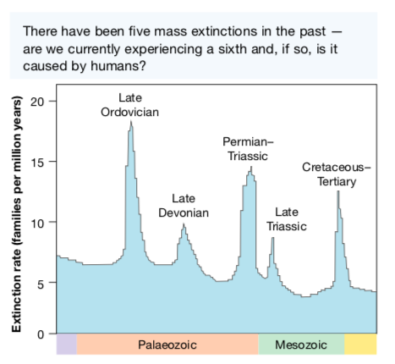
Mass Extinctions

Many scientists believe that we are currently experiencing the sixth mass extinction.

Five other mass extinctions have occurred as a result of global climate change. Some argue that humans are responsible for the current mass extinction.

The International Union for Conservation of Nature has reported that species are dying out 1000 to 10,000 times faster than they would without human intervention.

Those with the view that humans are to blame
divide this sixth extinction into two phases.
• The first phase began about 100,000 years ago
when the first modern humans began to spread throughout the world.
• The second phase began when humans started to use agriculture around
10,000 years ago.

